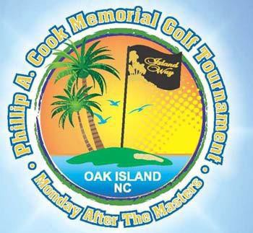

“Monday after the Masters” Monday April 13, 2020 – Oak Island Golf Club
The Premier Golf Tournament in this area Sponsored by Island Way Restaurant with all proceeds going to the Phillip A. Cook Education and Development Fund and WAVES 4 K.I.D.S.
Captain’s choice; Tournament fee, $125 per player, includes: breakfast, lunch, dinner afterwards, wine, beer, non‐alcoholic beverages, silent & live auctions.
Goodie bag, special tournament gifts, & prizes for 1st and 2nd in 3 flights.
Contests: Closest to the pin and Hole-In-One on all par 3’s, Longest drive on #18
Grand Prize for Hole-In-One on #12
For Registration and/or Sponsorship, visit www.waves4kids.org or send a check
made payable to WAVES 4 KIDS to: PO Box 162, Bolivia, NC 28422
For information, call Kay Wolf @910‐448‐0753, email: tkwolf48@gmail.com
PO Box 162 Bolivia, NC 28422
WAVES 4 KIDS is a 501(c)3 nonprofit organization, Federal Tax ID# 06-1732907, NC License # SL008027
Financial information about this organization and a copy of its license are available from the State Solicitation Licensing Branch at 919-807-2214. The license in not an endorsement by the State.

