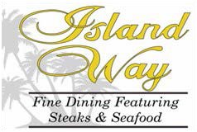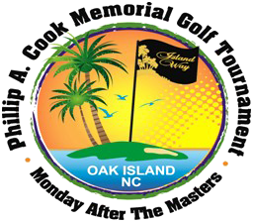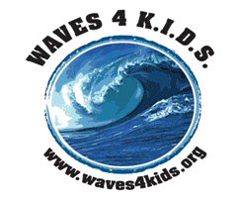

Sponsorship Form

Name and address:

Company name and address:

Phone Number:

E-mail address:

Sponsorship Levels:

Diamond – Hole sponsor sign with a full page ad in program, and 8 players : $5,000 Platinum – Hole sponsor sign with a ½-page ad in program, and 4 players : $2,500 Gold – Hole sponsor sign with a ¼-page ad in program: $1000
Silver – Hole Sponsor Sign with a 1/8-page ad in program: $500
Bronze – Hole sponsor sign and a business-card ad in program: $250
Patron – Hole sponsor sign: $100

Donations for Goodie Bag

Golf related items, with your company logo on it is really appreciated. Tees, golf balls, towels, divot tools, sun kits, first aid kits, etc. Quantity needed: 144 each (12 dozen)

Goodie Bag Donation:

Charity Auction
Local merchants may donate items from their place of business to be auctioned off to the tournament participants. All money raised goes to The Phillip A. Cook Education and Development Fund,
and WAVES 4 K.I.D.S.

Donation:
2019 Phillip A. Cook Memorial Golf Tournament A Benefit for WAVES 4 K.I.D.S of Brunswick Co.
Sign and advertising artwork must be sent to waves4kidsbc@gmail.com, Deadline 3/25

WAVES 4 kids, PO Box 162 Bolivia, NC 28422; Website: www.waves4kids.org
WAVES 4 KIDS is a 501(c)3 nonprofit organization, Federal Tax ID# 06-1732907, NC License # SL008027
Financial information about this organization and a copy of its license are available from the State Solicitation Licensing Branch at 919-807-2214. The license in not an endorsement by the State.

